 | PolicyPilot | PRD

Product Requirement Document
PolicyPilot — An AI-First Health Insurance Marketplace
An AI buying assistant where every recommendation is actionable and the journey — from first question to active policy — completes in one flow. This document covers the problem, solution, end-to-end flow, lifecycle, architecture, and design.
About this document
A product requirements document for an AI-first health insurance marketplace. It diagnoses why current AI assistants stall before purchase, then specifies a smoother product where recommendations are actionable and the whole journey completes in a single guided flow. Version 1.0 · Confidential.

1. The Problem
Today's AI insurance assistants (like PolicyBazaar's PB Buddy) start a conversation well but stall before the user can buy. Three gaps cause most of the drop-off:
- Recommendations are dead ends — plans appear as plain text — no card, no “View,” no “Buy.” The user can't act and leaves to search elsewhere.
- The flow is fragmented — questions appear in isolation, with no progress shown and no sign that earlier answers are remembered.
- No handoff to checkout — even a decided buyer has no in-context path from “this plan” to “I'm covered,” and must re-enter known details.

Issue observed | User impact | Business impact
Plans as plain text, no buttons | Can't act on the recommendation | Drop-off right after recommending
No View / Buy links | Must leave the chat | Lost conversions
No progress, isolated questions | Unsure how long it takes | Mid-funnel abandonment
Answers not visibly remembered | Repeats info, loses trust | Lower completion
No chat-to-checkout handoff | Re-enters known data | Friction at peak intent

2. Understanding
The user is a first-time or infrequent buyer in India, usually on a phone, who finds insurance jargon confusing. They want guidance, plain language, and a fast route to coverage. The current product is good at talking but treats itself as an information service, not a place to transact — so it abandons users at the exact moment it creates value. The fix isn't a better chatbot; it's making the whole journey happen in one continuous flow.
Design principles
- Always actionable — every recommendation has a button.
- One continuous flow — intake to purchase is one journey with progress and memory.
- Plain language — jargon always paired with what it means for this user.
- Transparent nudges — the “best match” reason is shown; cheaper plans stay visible.
- Human safety net — “Talk to expert” is always one tap away.

3. The Solution: PolicyPilot
PolicyPilot makes the assistant the product. The same conversation that understands the user also shows actionable plan cards, a guided comparison, and a checkout pre-filled from everything already discussed.
Problem | PolicyPilot fix
Dead-end recommendations | Every plan is a card with View / Buy buttons
Fragmented flow | One guided flow with progress bar + remembered answers
No checkout handoff | “Buy now” opens a pre-filled, secure checkout
Confusing jargon | Every term carries a plain-language one-liner
Distrust of “best” | “Why this fits you” reasoning shown; cheaper plans visible

4. End-to-End Flow
One continuous journey. Each stage hands its context to the next, so nothing is re-entered.
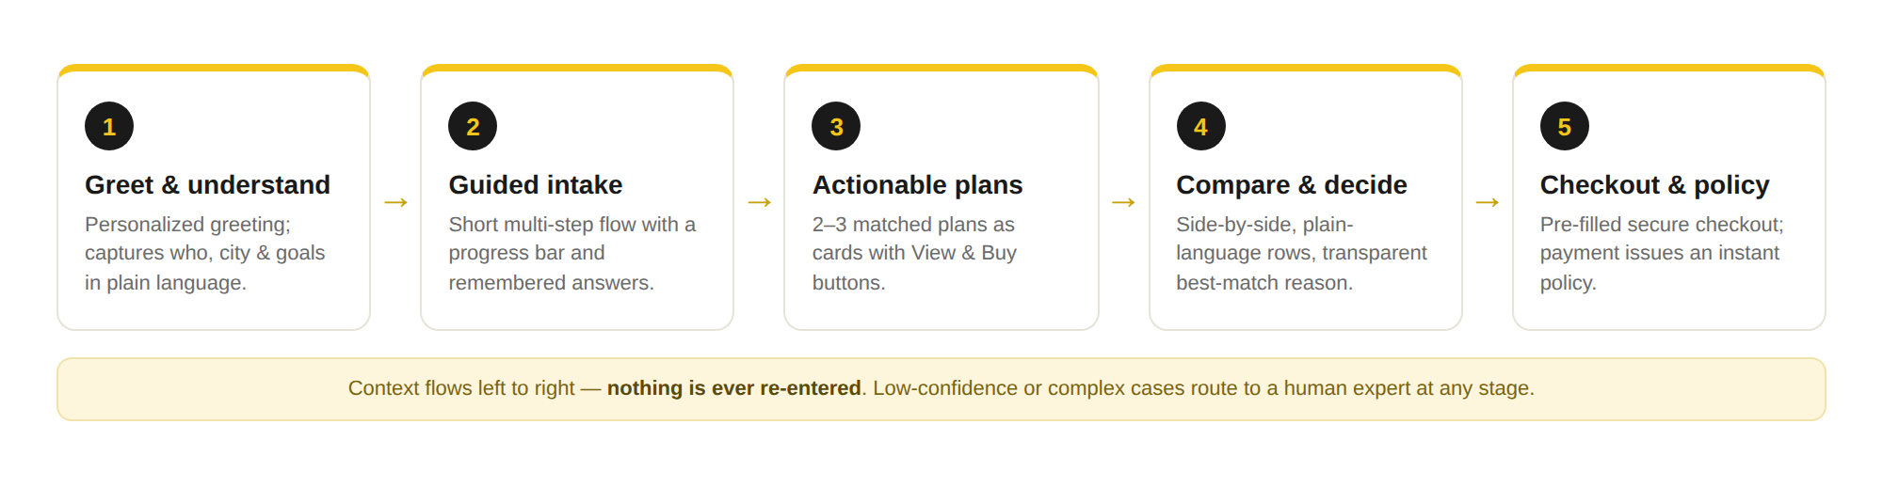
The five-stage PolicyPilot journey — context flows left to right

5. Product Lifecycle
The relationship extends well past the first purchase:
Phase | What happens | AI role
Discover | User opens the assistant | Personalized greeting, intent detection
Advise | Needs captured, plans matched | Recommendation + plain-language explainers
Decide | Compare and choose | Transparent best-match reasoning
Buy | Checkout and payment | Auto-fill from chat + ID, instant issue
Serve | Questions, endorsements | RAG assistant answers from the user's policy
Claim | File and track | Document AI reads bills, status updates
Renew | Reminders and re-quote | Re-assess needs, suggest changes
Build phases
- MVP — conversational intake + actionable cards + checkout, one insurer line.
- V1 — multi-insurer comparison, guided flow with memory, ID auto-fill.
- V2 — claims assistant, renewals, RAG policy Q&A, experimentation.

6. Architecture & Tech Stack
A layered, microservices-oriented platform. Clients reach the system through a gateway that handles auth and routing; domain services own their data; AI workloads run as separate services so they scale and version independently.
Architecture layers
- Client — React / Next.js web + React Native mobile; the assistant is a first-class surface, not a bolted-on widget.
- Gateway — API gateway with authentication, rate limiting, WAF, and routing.
- Domain services — Profile, Quotes, Plans/Catalog, Checkout/Orders, Policy, Payments, Notifications — each independently deployable.
- AI services — Conversational orchestrator (LLM), recommendation engine, document AI (OCR/NLP), and a RAG service for policy Q&A.
- Data — PostgreSQL (transactional), vector DB (RAG), Redis (cache/session), object storage (documents), warehouse (analytics).
- Platform — Event bus, observability, CI/CD, secrets management, and an immutable audit log spanning every layer.

Recommended stack
Layer | Recommended | Alternatives
Web frontend | React + TypeScript, Next.js | Vue / Nuxt
Mobile | React Native | Flutter
Styling | Tailwind CSS | CSS modules
API gateway | Kong / AWS API Gateway | NGINX, Apigee
Backend | Node.js (NestJS) + Python (FastAPI) | Go for hot paths
LLM orchestration | LangChain / LlamaIndex | Custom orchestrator
LLM | Hosted API or self-hosted Llama | Mix per use case
Recommendation | Rules + LightGBM ranking | Vector similarity
Document AI | Cloud OCR / LayoutLM | Tesseract + NLP
Transactional DB | PostgreSQL | MySQL
Vector DB | Pgvector / Pinecone | Qdrant, Weaviate
Cache / session | Redis | Memcached
Message bus | Kafka | RabbitMQ, SQS
Payments | Razorpay / Stripe | PayU, Cashfree
Object storage | S3 / GCS | Azure Blob
Warehouse | Snowflake / BigQuery | Databricks
Orchestration | Kubernetes | ECS
CI/CD | GitHub Actions + ArgoCD | GitLab CI
Observability | Prometheus, Grafana, OTel | Datadog
Auth | Keycloak / Auth0 | Cognito
Actionable-recommendation contract
The assistant never returns plain text for a plan. The recommendation service returns structured objects — plan_id, insurer, name, premium, sum_insured, key_features[], match_reason, view_url, buy_url, compare_token — and the UI must render each as a card with View and Buy actions. A plan with no buy_url cannot be shown. This makes dead-end recommendations structurally impossible.

7. Design Mockups
Sample screens showing how each problem is resolved. Design references, not final UI.

7.1 Actionable recommendations
The same plans PB Buddy lists as text become cards — premium, plain-language features, a best-match reason, and Buy / View buttons. This fixes the dead-end problem directly.
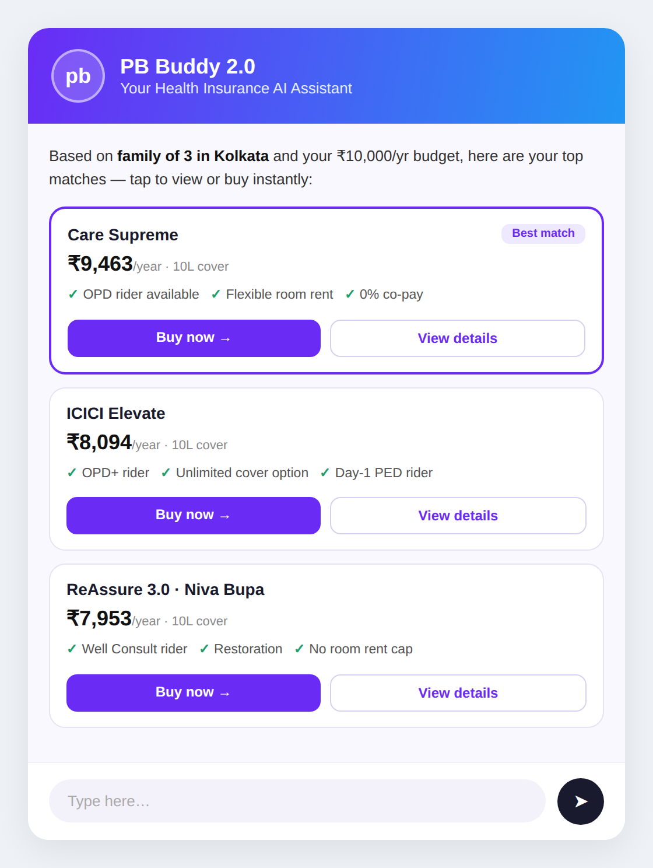
Mockup 1 — AI chat with actionable plan cards

7.2 Guided flow with progress
The isolated “sum insured” question now sits in a 5-step flow with a progress bar and a banner confirming earlier answers are remembered.
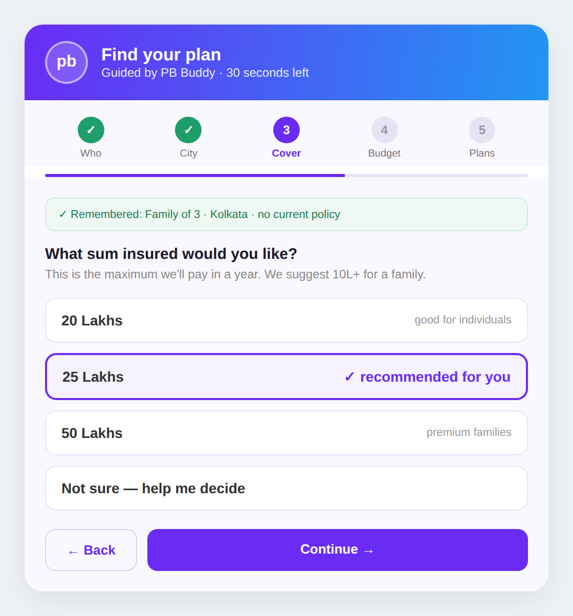
Mockup 2 — Guided intake with progress and memory

7.3 Plain-language comparison
Coverage lined up side by side, each term explained in one line. The best match is accented with its reason; cheaper plans stay fully buyable.
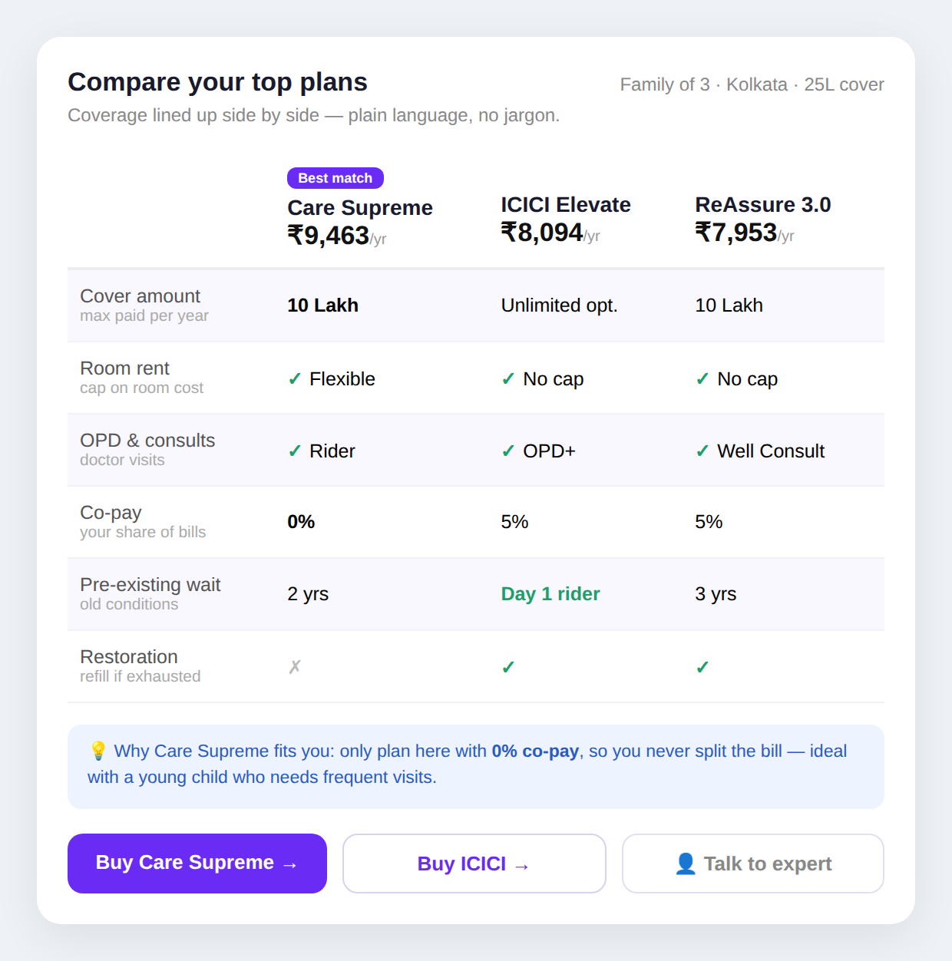
Mockup 3 — Side-by-side comparison with plain-language rows

7.4 Seamless checkout
Choosing a plan opens a checkout carrying everything from the chat and ID. The user confirms rather than re-enters, and payment issues an instant policy.
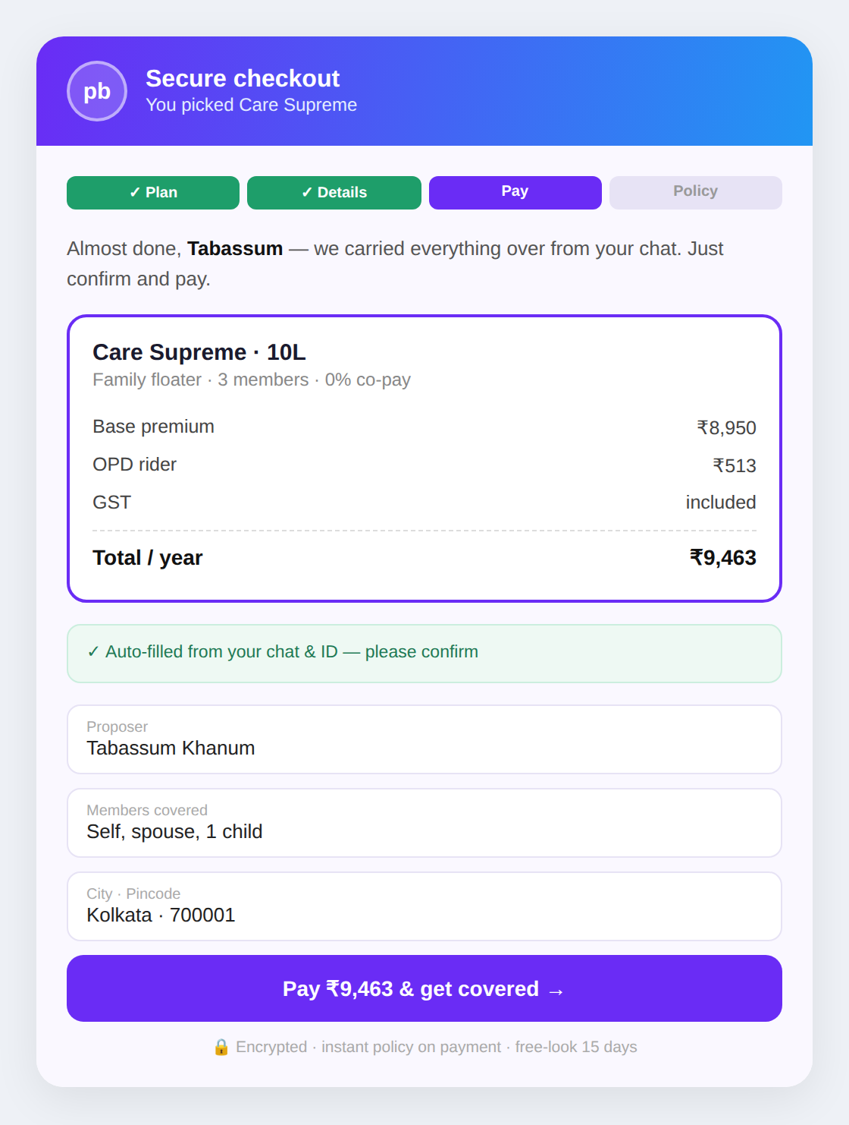
Mockup 4 — Pre-filled secure checkout

8. Metrics, Risks & Scope
Success metrics
Metric | Target
Recommendation → action rate (the dead-end fix) | > 40% tap View / Buy
Flow completion rate | > 60% finish intake
Chat → purchase conversion | 2–3× baseline
Time to purchase | < 10 minutes
Assistant containment (no human needed) | > 55%
Targets are planning estimates; validate against real funnel data.
Key risks
Risk | Mitigation
Unsuitable plan recommended | Show reasoning, keep cheaper options, human safety net
Inaccurate plan facts from LLM | Ground in catalog (RAG); verify premiums vs system of record
Regulatory non-compliance | IRDAI-aligned disclosures, audit trail, legal review
Over-automation at checkout | Confirm-before-submit; clear free-look period
Out of scope (Phase 1)
- Non-health lines (motor, life, travel) — added later on the same platform.
- Full claims adjudication engine — the claims assistant arrives in Phase 2.
- Agent / broker commission management.

